CLOUD APPLICATION AND DEVELOPMENT
Arpita Kasaudhan
500086690
Batch : 03 CCVT
HORIZON

Horizon is basically a web based graphical user interface that helps user to interact with other OpenStack services like networking, storage, compute etc. Horizon is one of the fundamental part of OpenStack and is built on the top of open Stack API’s It is used to interact with the OpenStack services, such as Neutron, and Cinder, Nova , through their APIs to perform various tasks, such as launching instances, creating networks, and managing volumes.
Horizon makes it easy for cloud administrators and users to access and manage their resources while also streamlining the difficult tasks associated with running a cloud infrastructure. Additionally, it offers thorough analytics and statistics to assist users in managing and maximising their cloud resources.

In conclusion, Horizon is a strong and adaptable web-based dashboard for OpenStack that makes it simple for users to manage and keep an eye on their cloud infrastructure.
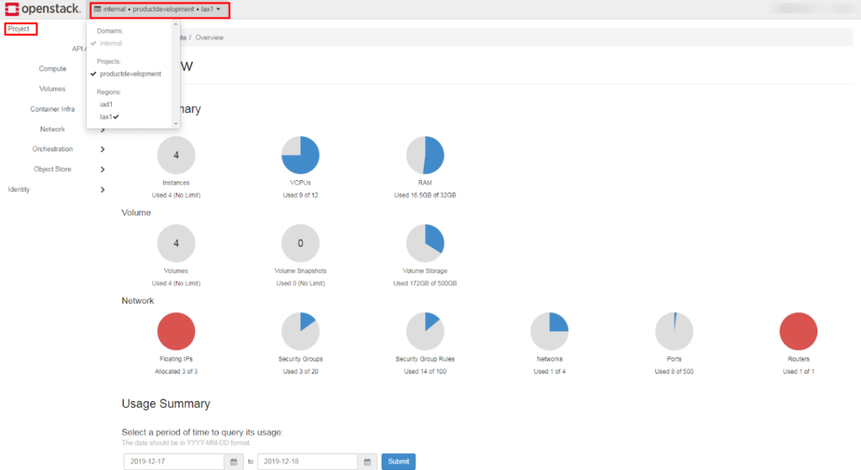
Horizon(dashboard)

